University of Utah
School of Computing
CS 6967: Security Operations

Lab 7 Response Outline

Lab 7: Jump Server
Test 1: Jump Server to Run Inside LAN
Summary of test experience:
The goal of the test was to check if the jump server VM was running inside the LAN. To do so, after importing the VM, I had to configure the network settings of the VM within the NAT Network.
Screenshot of test results:
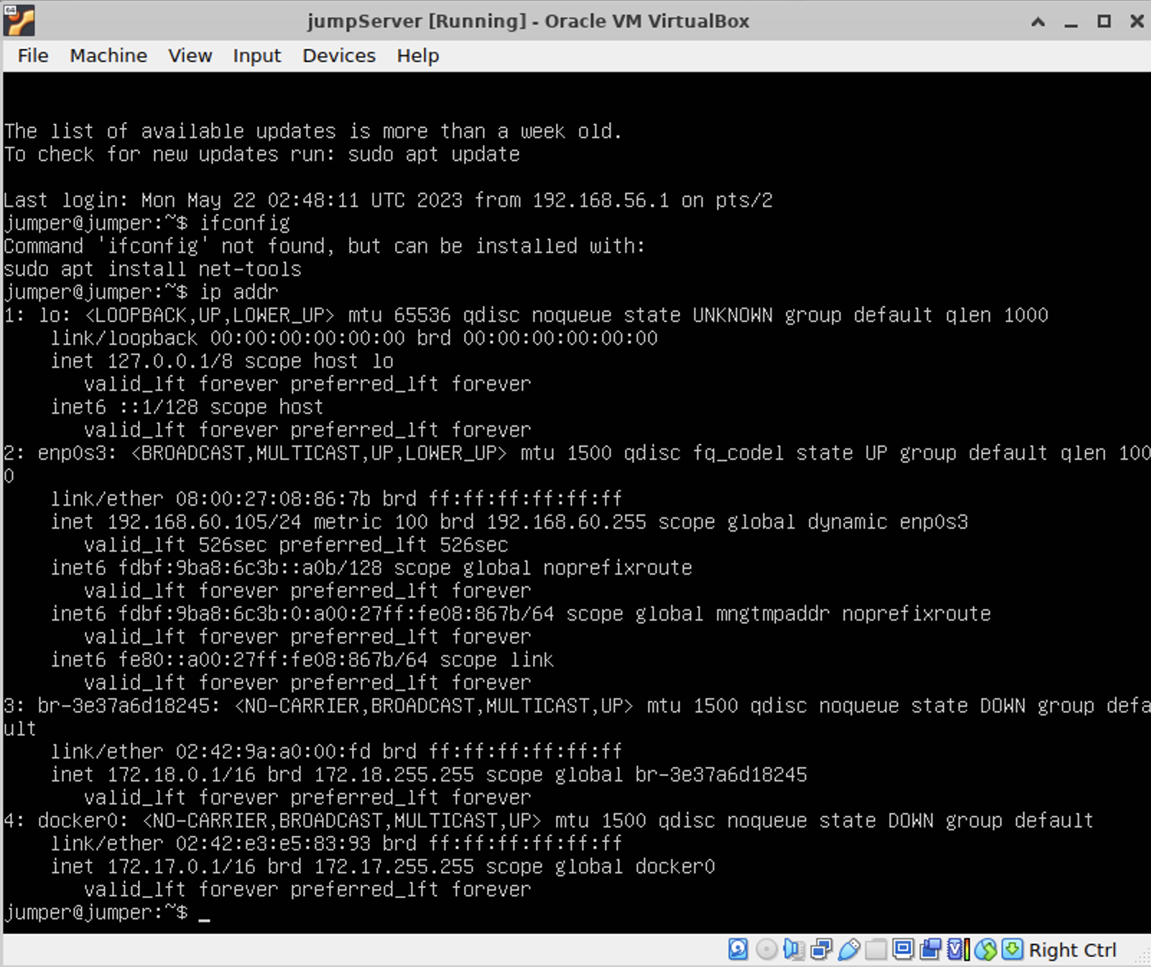
How does the image demonstrate that you completed the test?
After running ip config in the VM terminal, the IP address information was found and the IP address for the jump server within my LAN network range 192.168.60.__ /24, which in this case was 192.168.60.105/24.

Test 2: Web Server Accessible From the WAN
Summary of test experience:
Now the test was to check if the webgoat web server was accessible from the WAN after we configured the jump server. At first the jump service was started from the terminal. Then some additional firewall rules were set up now that the jump server was added to the network. After that, the warpgoat admin web page was accessed via the IP of the jump server and the port set up. A target with all admin access was configured which was basically the webgoat server within the WAN. Finally, using the same port, an attempt was made from the web browser of Kali Linux VM using the router’s IP and the port used for the jump server now, which eventually proved that the test was working.
Screenshot of test results:
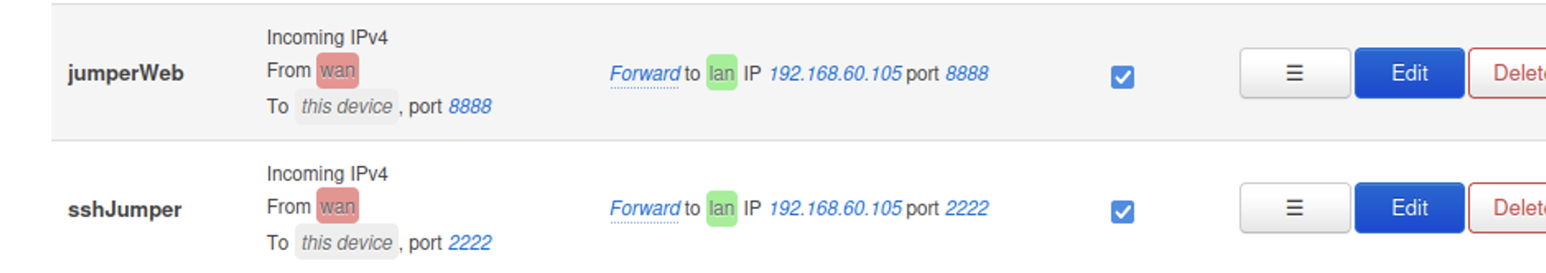
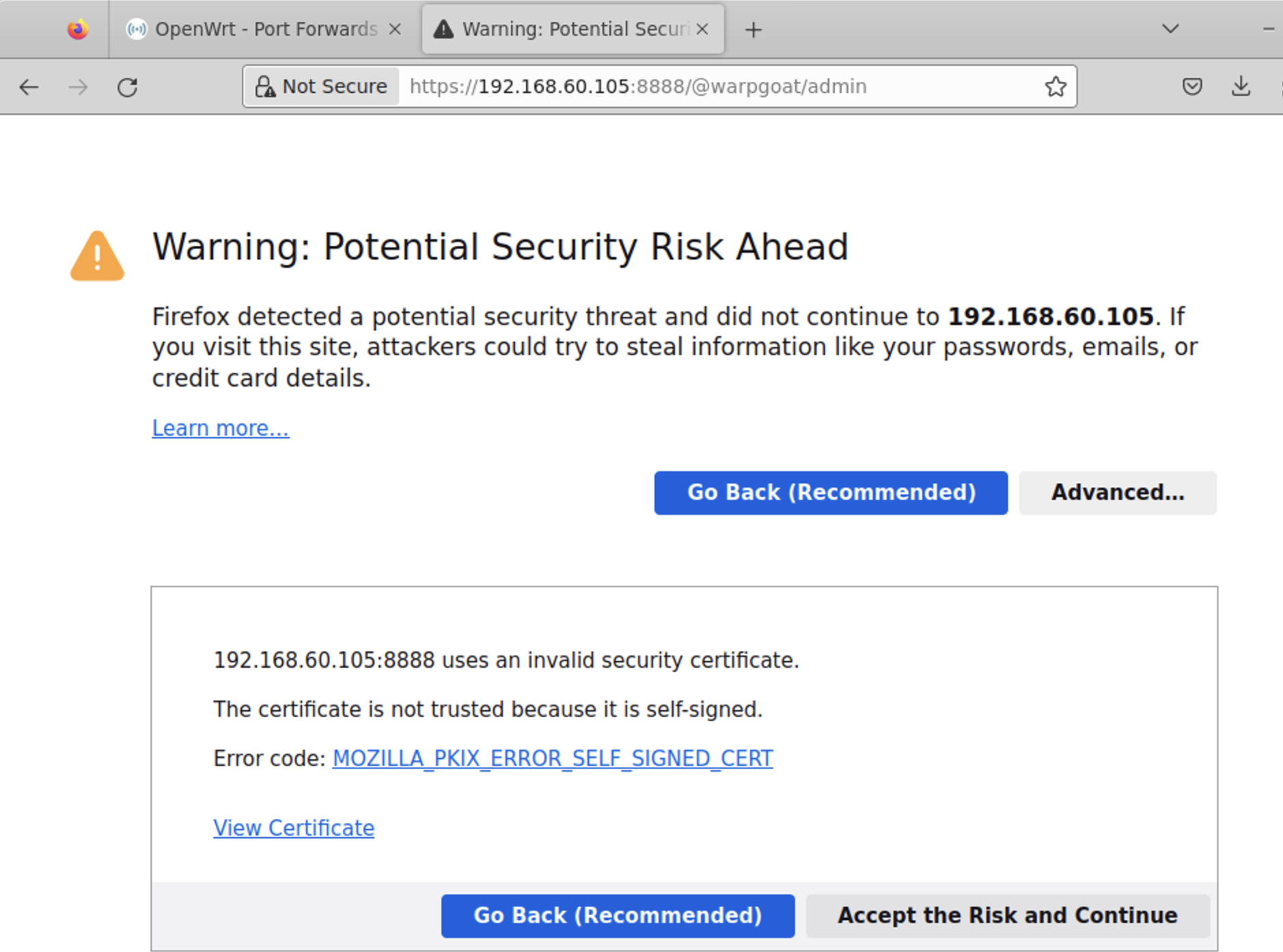
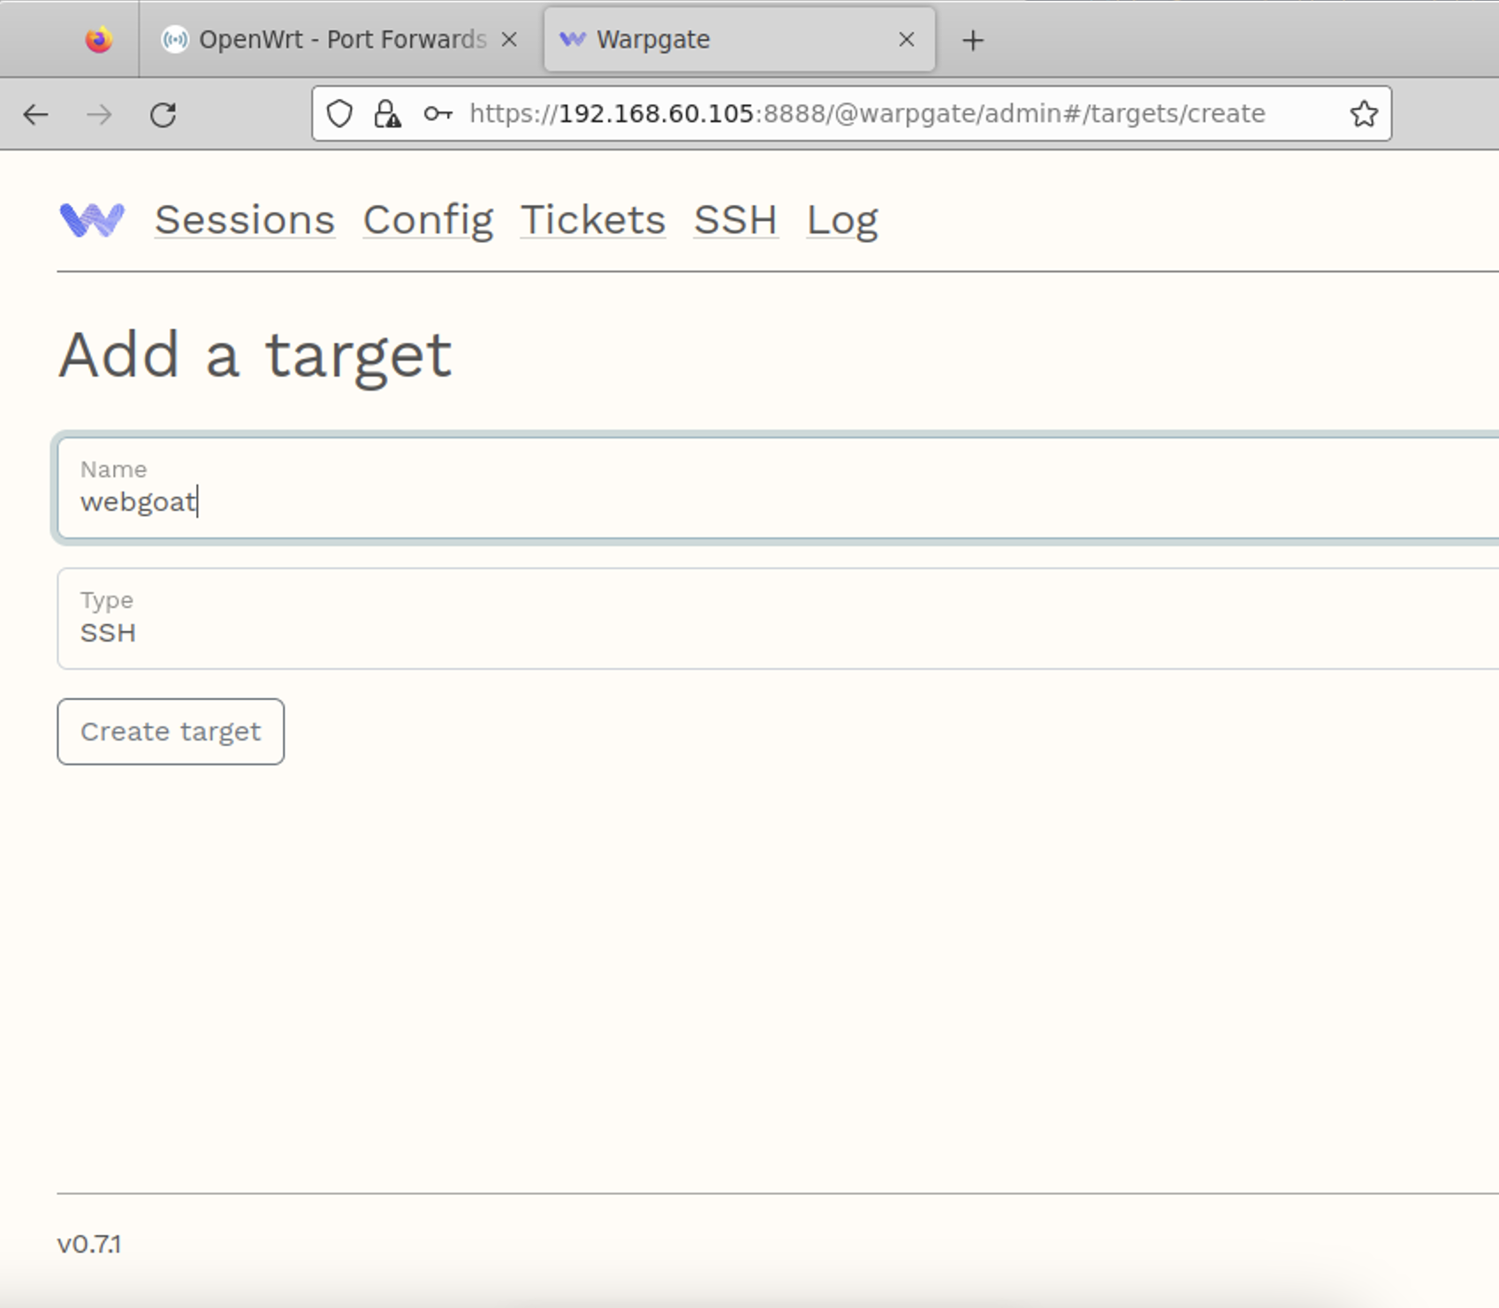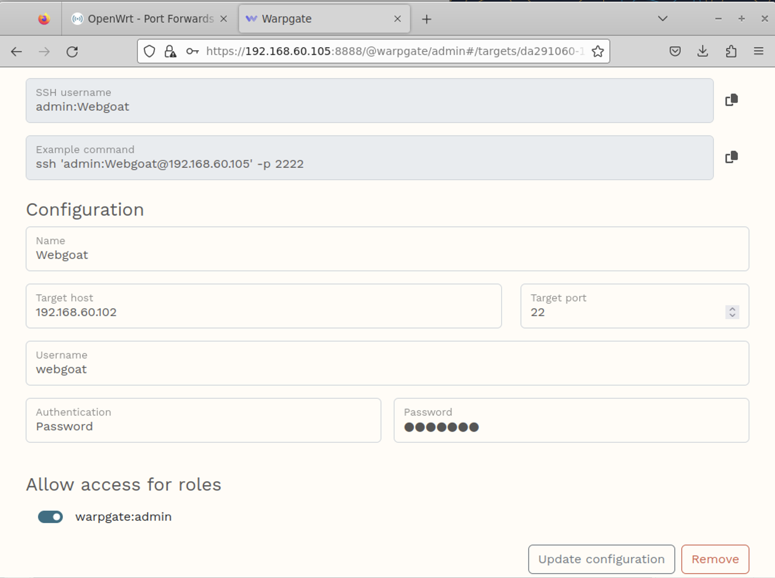
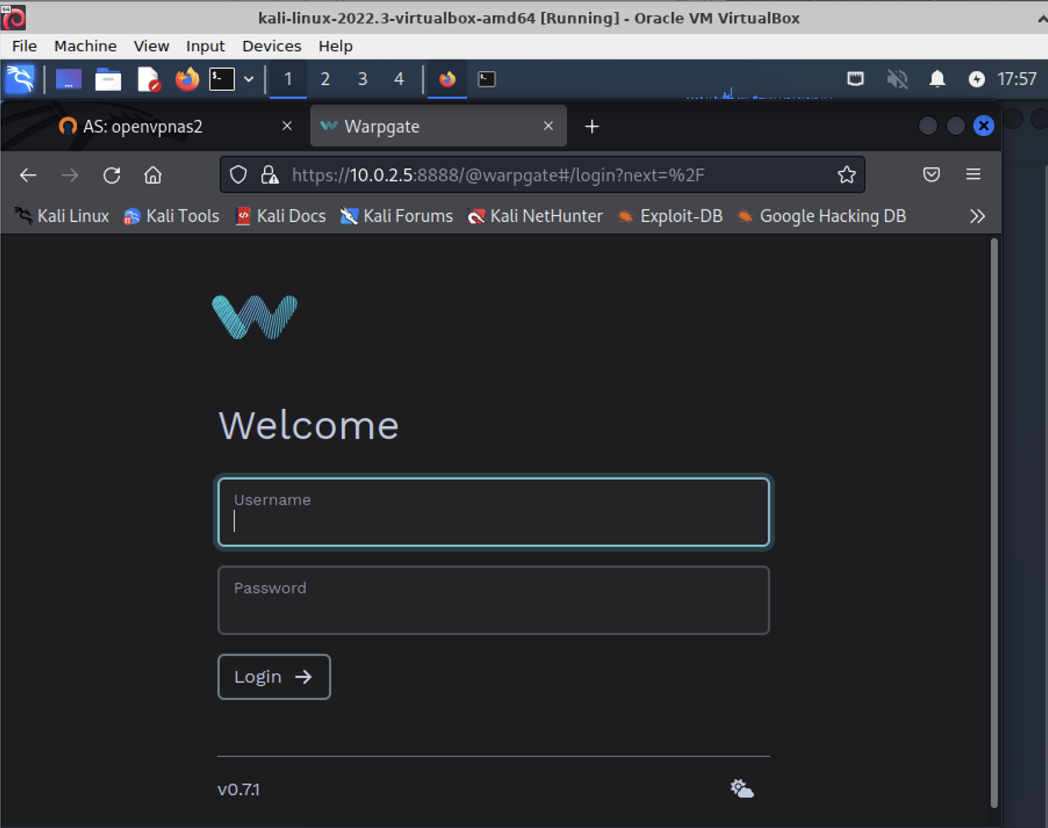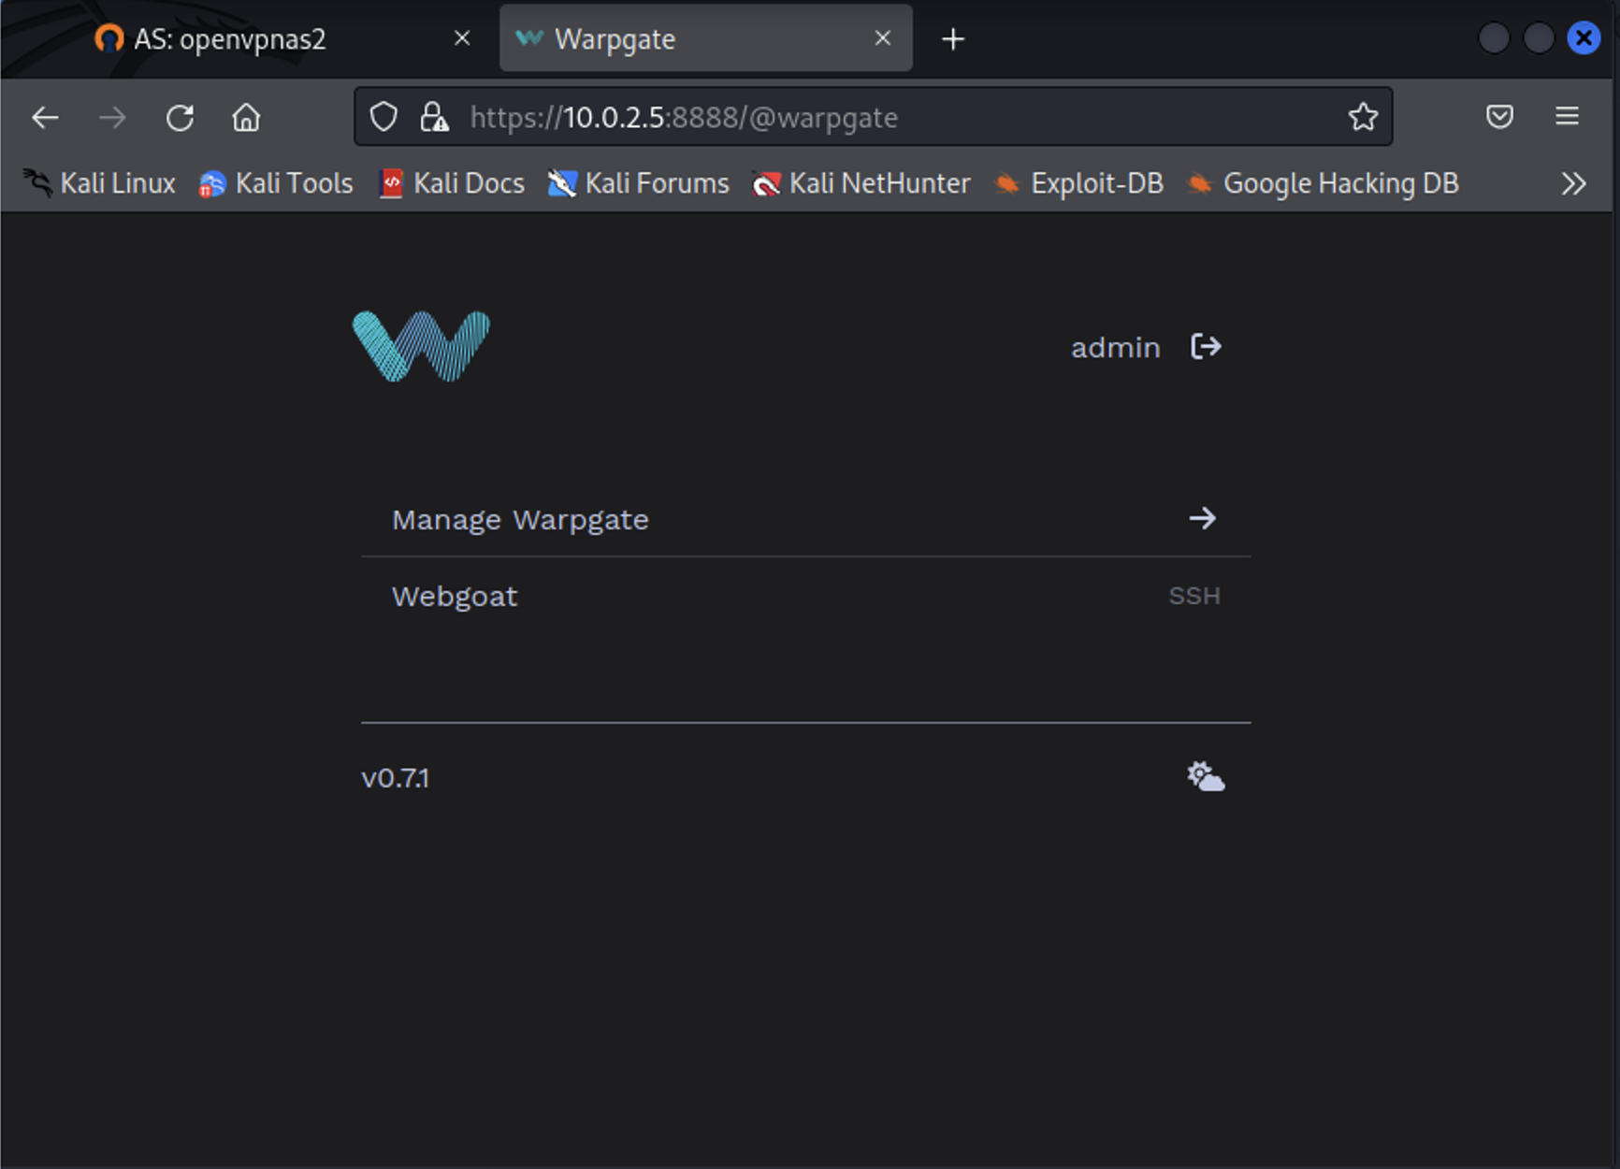

How does the image demonstrate that you completed the test?
Since the warpgoat website as an admin could be accessed from the Kali Linux server, it meant the web server was accessible via the jump server within the WAN.
Test 3: SSH into the Web Server
Summary of test experience:
The final step of the test was to check if I could SSH into the web server via the jump server. To do so, I ran the command ssh ‘admin:Webgaot@10.0.2.5’ -p 2222 from the kali linux terminal.
Screenshot of test results:
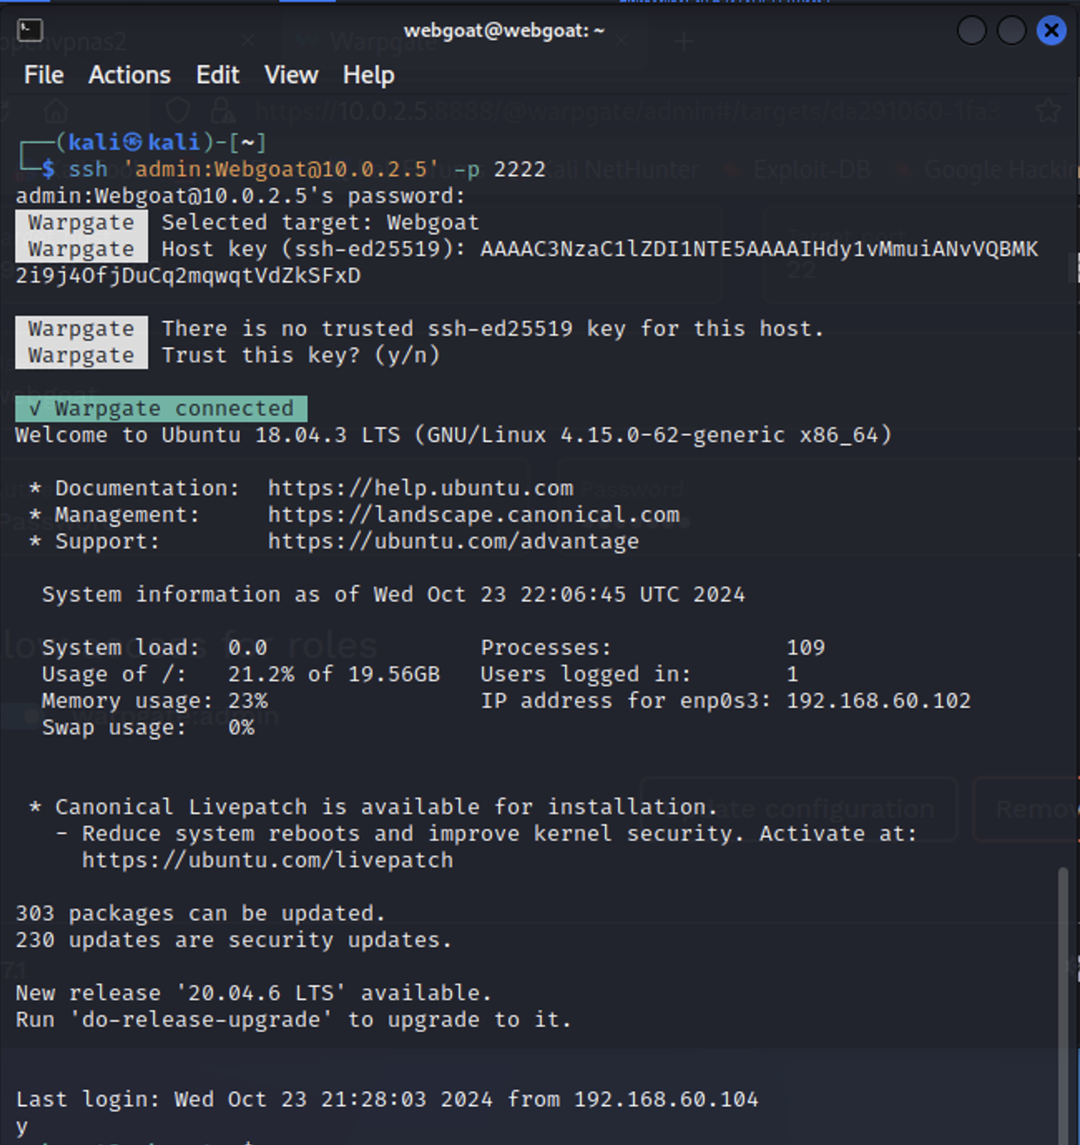

How does the image demonstrate that you completed the test?
After running the command, it showed login times, and other system information, which implies that I could SSH into the web server successfully.

